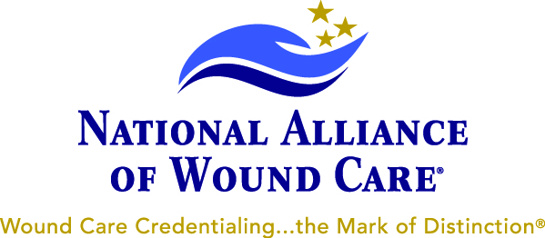

For Immediate RELEASE:

National Alliance of Wound Care® Introduces New Certification in Ostomy Management
There is a significant need for more certified experts who will care for patients with Ostomies

Lake Geneva, Wisconsin- September 13, 2012 National Alliance of Wound Care (NAWC®), the nation’s largest wound care credentialing board, announced today the introduction of their newest certification program in the specialty of ostomy management. The credential, Ostomy Management Specialist^{sm}, (OMS) is the fourth wound care related certification program available from NAWC.

Each year, more than 120,000 Americans receive stoma surgery that creates a possible, life-long ostomy. It is a goal of NAWC to meet the growing need for more certified experts in ostomy management by offering this new credential. “The Ostomy Management Specialist certification program is a huge milestone for us as we can now offer this professional credential to the healthcare community including our 13,000 certificants. By expanding our offerings, we are truly leading the wound care industry in this new century. Physicians, Therapists and all nurses can now obtain the tested competency and recognition as a specialist in Ostomy Management to help their patients’ and advance their careers”, said NAWC Executive Director, Debbie Hecker RN, MBA, WCC, DWC.

As part of NAWC’s 10th anniversary celebrations, the organization introduced this new credential at their annual conference in Las Vegas, clearly setting them apart from any other wound care credentialing board. The National Alliance of Wound Care asks that we remember the date, OCTOBER 6, 2012 – World Ostomy Day & Ostomy Awareness Day.

About NAWC
NAWC is a non-profit organization, dedicated to the advancement and promotion of excellence in wound care through their certification programs. The NAWC is among an elite group of more than 90 credentialing organizations that have received and maintained National Commission for Certifying Agencies (NCCA) accreditation. For more information about the NAWC’s certification programs, visit http://www.nawccb.org

Contact Information:
Fred Berg, CWCMS
VP Marketing and Business Development
National Alliance of Wound Care
877-922-6292, ext 706
Fax: 1-800-352-8339
fberg@nawccb.org

